You Are My Bride, My Garden Sealed
May 27, 2016
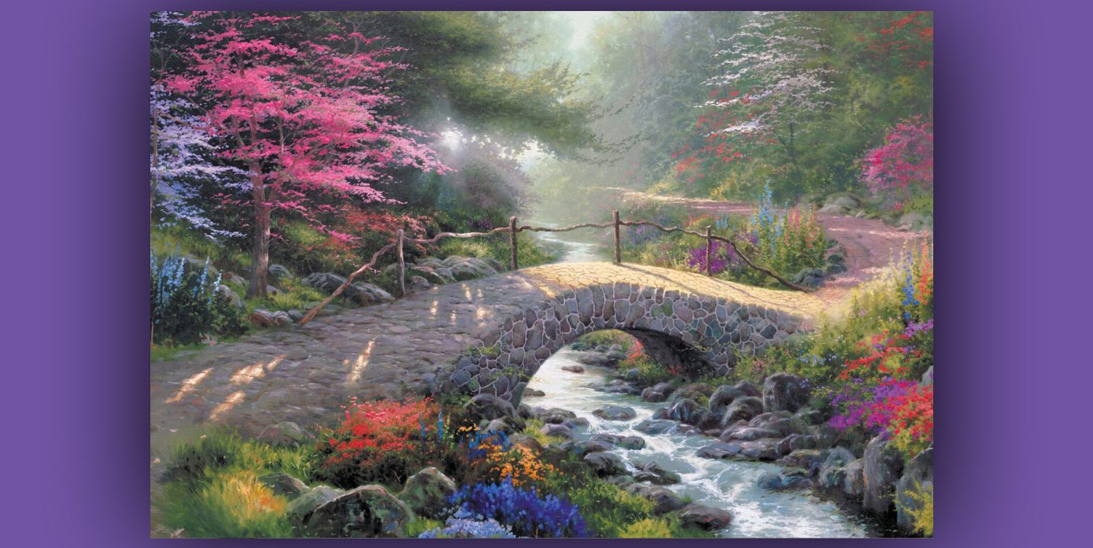
May the sweet presence of the Lord enfold you, dear Heartdwellers. May the blessings in this message be taken in and hidden in your hearts.

I fell asleep and rested after worship, which happens quite often, for all of you who feel guilty about falling asleep during or after worship. After my brief rest, I came into prayer again saying, “Here I am, Lord.” Although I didn’t see Him at all, I knew He must be present. This does not bother me, because He does this many times as a fast offering for me and showers the grace on others who haven’t seen Him before.

He answered me, “I’m right beside you. Relishing your discovery of how much I love and honor you. I want to speak to My Brides about how much comfort they bring Me.

"My dear ones, stop obsessing over whether or not you will be taken in the Rapture. I have told you before, as long as you have broken with sin and doing your best to stay out of sin, I will take you. When you fall, come running to Me in deep contrition. I will immediately restore you. There are elements of power beyond your comprehension that have made a generation of addicts. The struggles are fierce with these powers and many fall repeatedly because of them.

"I see the heartbreaking struggles you go through. I see your tears and resolve to stay away from sin. I see and I honor, so do not fear to come to Me when you fall. I wait for you with open arms. Understand that I do see everything about your life and I know where you are sincerely trying and where you are not. I am a God of forgiveness and restoration. When you have done your best, your very best and still fail, humility is worked deeply into your soul. Did I not say tax collectors and prostitutes will enter Heaven before the self-righteous? Indeed, I did. And whether you are aware of it or not, your weakness has kept you from joining ranks with those who congratulate themselves that they are not like other men.

"When I see your devotion, your daily struggles, your fresh resolve, your careful examination of conscience and self-correction, I rejoice that such a one as this has given their lives to Me. I find great solace and joy in dwelling in your hearts and listening to the meditations of your mind as you continue to draw closer and closer to Me, until we are one. I see your dry spells and watch your grief when you do not feel My presence, though I am with you always.

"I see how you recommit your life to Me sometimes hour by hour, day by day, saying over and over again, 'I just want more of You, Jesus. I want to love You with my whole heart.' I hear the times you cry out from the heart, 'Lord, have Mercy on these souls.' I approve the meditations of your hearts and the faithfulness you reach for daily.

"How can I possibly describe to you the indescribable joy you bring Me? You are like a garden filled with luscious roses of all different colors and marvelous fragrance. Jasmine, lavender and lilacs grow in profusion. Hidden between the beds of roses are precious lilies of the valley giving off their own divine fragrance. Yes, your good deeds are manifested to Me and all of Heaven with a supernatural fragrance. The dew drops, rolling down each petal of the rose, sparkles with delightful rainbows of color. The stones along the path are exquisite agate slabs, displaying intricate lacy patterns that reflect the hills of Heaven.

"The birds that nest in your garden sing praises continually in this sheltered place of worship and peace. There they raise their young on the finest seeds and fruits. Your fruit trees are continually bearing the most delectable fruits. And this abundance is spread abroad, bringing nourishment to other souls whose gardens are not yet in full bloom.

"Even if I were to spend the rest of the night explaining to you the beauty of your souls, I could not do so adequately. I only make this feeble attempt to point you in the right direction of understanding who you really are before Me. And I know you well, My Brides - you will not accept these praises readily, for all credit is returned to Me, your Creator. Nevertheless, your beauty is outstanding and I would be remiss if I did not at least attempt to describe to you what I see and experience in your presence.

"I need these gardens to walk in at the cool of the day. The cries of the oppressed are ever before Me and when I enter your gardens, the fruit that you have borne answers My need to see graces fall upon good soil and bear good fruit. You are refreshing, rejuvenating, encouraging, as you bring delight to My Soul. This is why I shed these graces abroad, so that they will eventually fall on good soil and bring forth a worthy harvest.

"When I see such things wasted while humanity cries out to Me for comfort, it brings Me great sadness. Did I not plant good seed? Did I not water and weed, fertilize and prune? Where then is My harvest? Souls are crying out to partake of this fragrant garden and healing fruits. I planted…where is My crop?

"You, My faithful Brides, are the answer to My prayers and through you I nourish many faltering and desperate souls. I have never demanded that you be perfect in every aspect, only that you be perfect in your love for Me and for your brother. When you set forth to accomplish that, I go with you and together we bring the lost to the banqueting hall of our love.

"So, put away your fears. I am coming for you. If you fall, coming running to Me in repentance, get up with a new infusion of My grace and try again. That you continue to get up is a marvel of grace that alone suffices to bring Me joy. Soon, your falls will be further and further apart and as you learn how much you are loved, how secure you are in Me, the powers of evil will lose their grip on you.

"So, run to Me, My Bride, and put away the lies of the enemy. I am coming for you; your hope and faith will not be disappointed. You have known Me as the Merciful God, so shall you know Me as the God of Glory as I transform your very bodies into the likeness of Mine."

You are my hidden garden, My treasure, My Bride, a secluded spring, a fountain sealed. Song of Songs 4:12

